Raw Material Register

1)The Receipt ID is generating from 2 instead of 1.

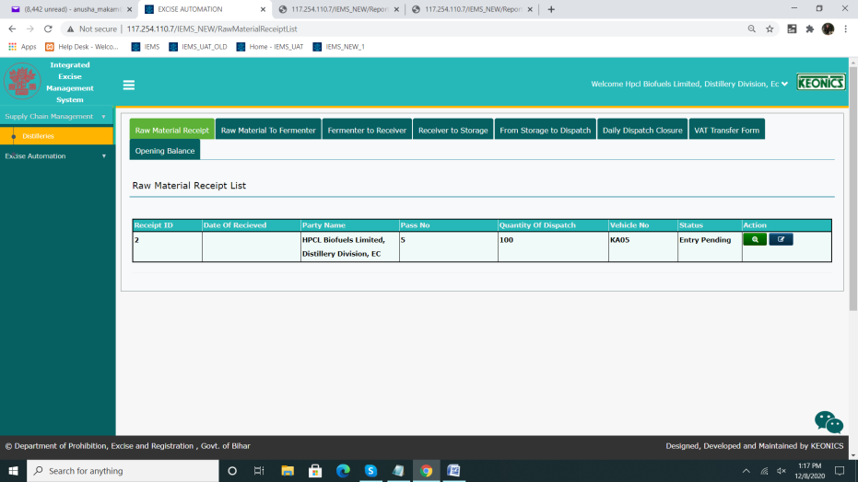

2) Date field currently allows entry of characters. The text box should be read only and allow the selection only through calendar control.

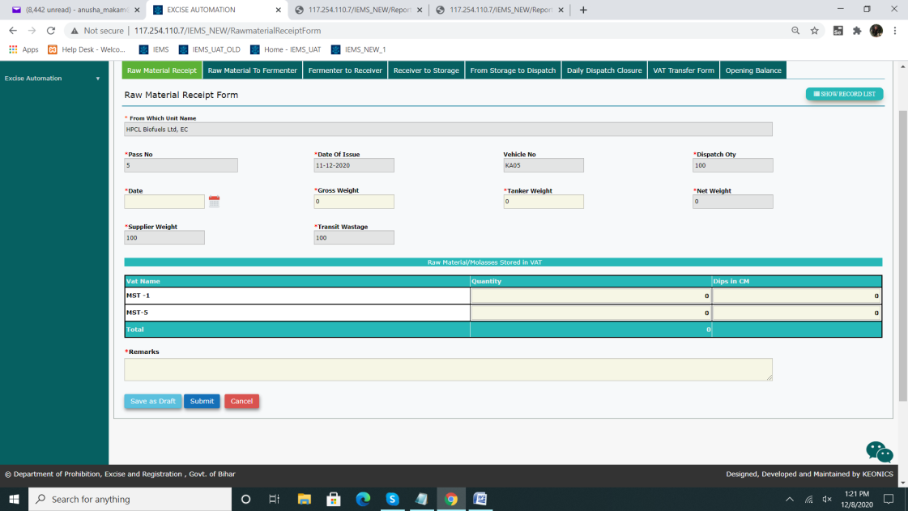

3)Cancel Button- Doesn't navigate to RMR list view in case clicked on Cancel. Functionality required.

4) Gross weight can not be less than the supplier weight, if the Gross Weight entered by user is less than the supplier weight then system would prompt a message as (“Are you sure Gross weight enterd by you is correct as Gross Weight cannot be less than the supplier weight (Yes/No)?'

Are you sure Gross weight enterd by you is correct as Gross Weight cannot be less than the supplier weight (Yes/No)? (Based on the document)

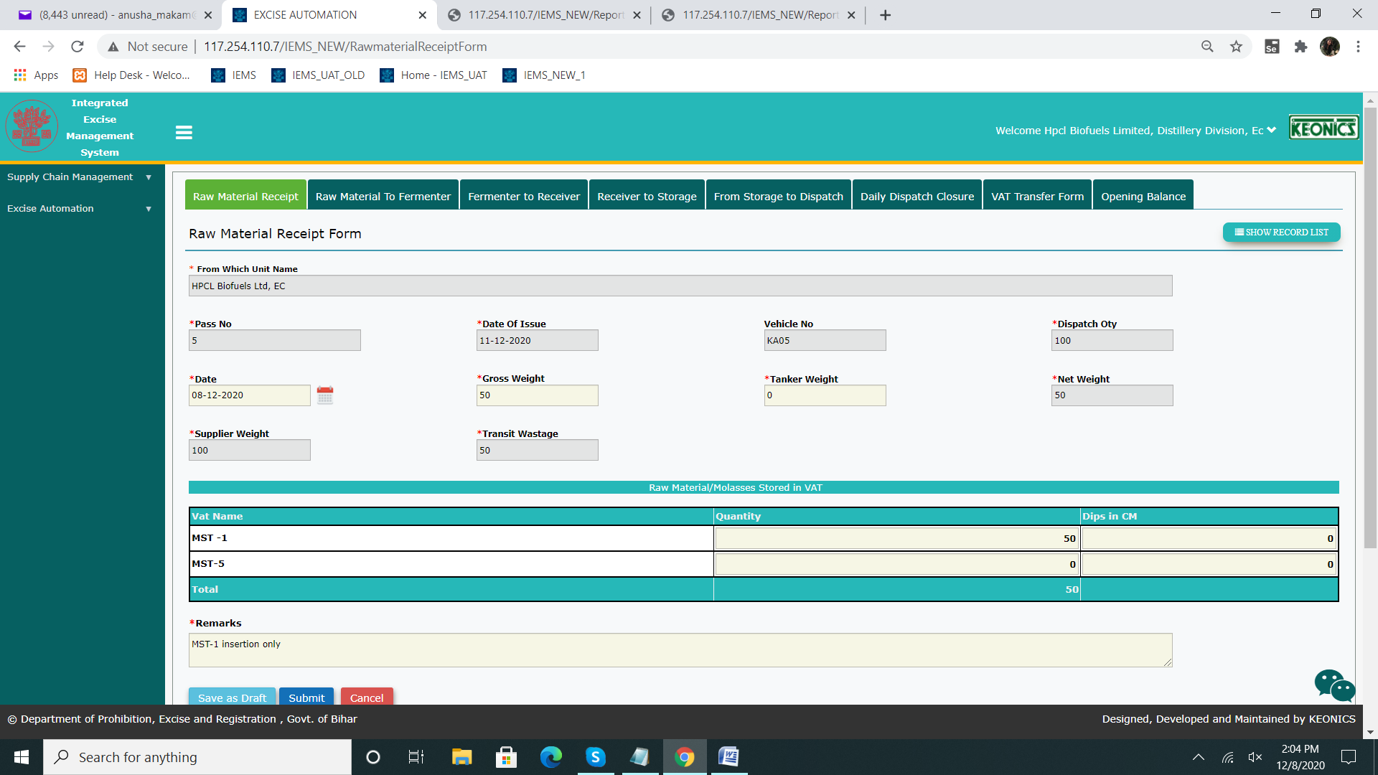

5)Clarification: Based on the referred document ,Supplier Weight, Transit Wastage should be User Input Fields.(Currently auto-populated)

7) In RMR Form, For Dispatch Qty field,---> Qty should be replaced instead of Oty

8)In RMR for--> Remarks fields requires alert pop-up. (Mandatory field)

9) As per document, The sum of the Qty Stored value in Grid should be equal to the dispatch. Currently total is compared to net weight.

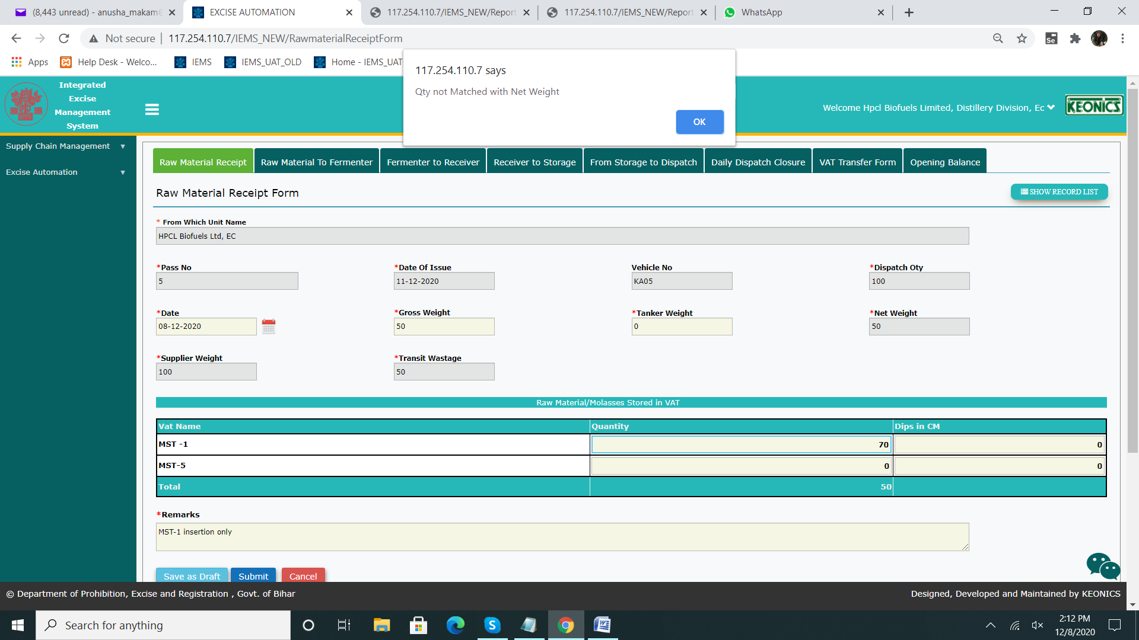

10) After a Bond officer Rejects the record, the Approver summary--> User Remarks gets updated instead of Approver remarks in 'Approver Comments field' in both both BO and User login.

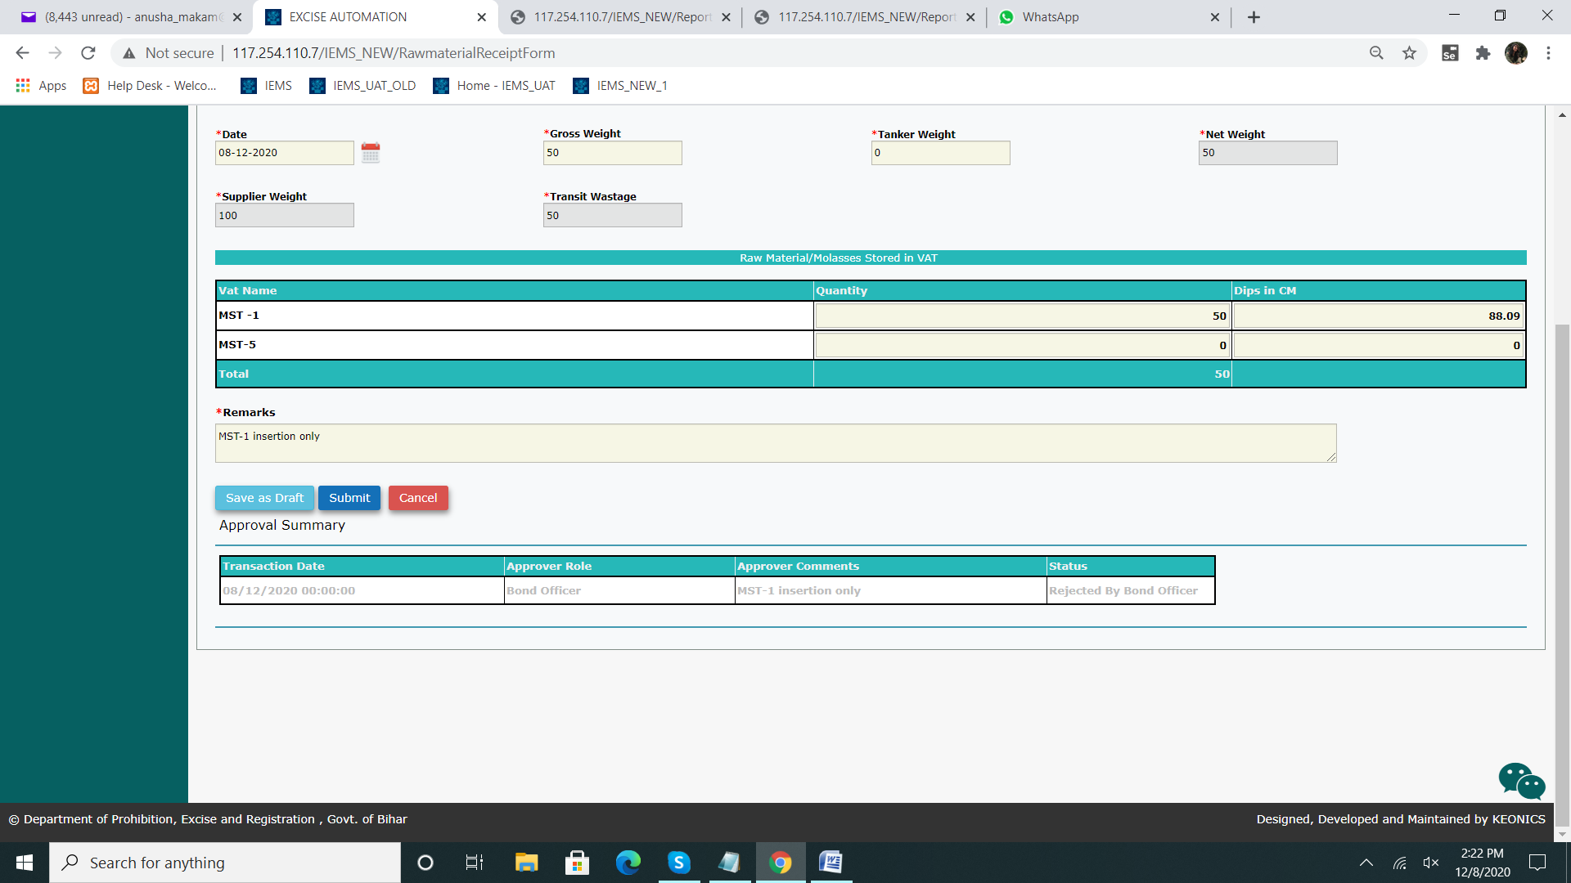

11) Net weight, Transit Wastage should not display negative values.

12)Unable to Approve the record at bond login(BLOCKER)